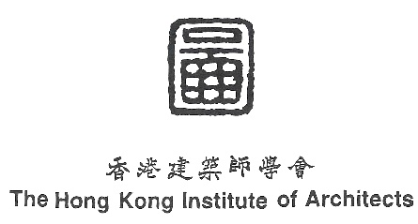
The Hong Kong Institute of Architects
65th Anniversary Project – “Humanity Bank”
Submission Form

To: |  | HKIA Secretariat Ms. Winnie HONG
Email: |  | hkiasec@hkia.org.hk
Deadline: |  | 31 January 2022, Monday, 12:00pm
A ENTRANTS’ PARTICULARS
Entry type: □ Individual □ Team □ Company
For INDIVIDUAL participation
Name: |  |  |  |  |  | HKIA Membership no.:
Date of birth:  (dd/mm/yyyy) |  |  |  | Tel.: |  |  | Email:
For TEAM participation
# | Name: |  | HKIA Membership no.:  (if applicable) |  | Date of birth:  (dd/mm/yyyy) |  | Tel.: | Email:
For COMPANY participation
Company name: |  |  |  |  |  | HKIA Corporate Membership no.  (if applicable)
Contact person: |  |  |  | Tel.: |  |  | Email:
Remarks:
- For team participation, please insert additional row(s) to fill in team members’ information if necessary.
- For enquiries, please contact Ms. Crystal CHAN at 3155 0422 or hkiasec@hkia.org.hk.

B PROJECT DETAILS
Project title:
Project year: |  | Location:
Project Description (about 200 words)
Description how the project contributes with humanity (about 200 words)
Project Photos (5 Images)

C DECLARATION
By completing, signing and submitting this registration form, I / we* agree that-
- I / we* represent and warrant that:
  - I am / we* are the owner of all the intellectual property rights of the Submitted Work(s);
  - My / our* Submitted Work(s) and the display and use of my / our* Submitted Work(s) does / do* not violate the copyrights, contractual rights, intellectual property rights or any other rights of any person; and
  - the submission, display and use of my / our* Submitted Work(s) does / do* not result in a breach of contract between me / us* and any third party.

- I / we* note that the Submitted Works may be published. I / we* should take all the necessary steps to protect my / our* own intellectual property rights for the Submitted Works before submission if necessary. HKIA and any parties authorized by HKIA. shall not be liable for any loss, expense, damage or liability suffered or incurred by the Entrant(s) as a result of or in connection with any infringement or abuse of any design or intellectual property rights that may arise as a result of entry into the Project or as a result of any promotion and publicity works during and after the Project.

- I/ we* fully and unreservedly grant HKIA and any parties authorized by HKIA. all rights to copy, edit, publicly display, broadcast, publish and use, in whole or in part, the Submitted Work(s), for non-commercial exhibition and promotion purpose in any manner and any territory without any compensation and without the need to seek any prior consent from me/ us during and after the Project, except where prohibited by law.

- All decisions made by the Organizer are final and binding in all aspects relating to the Project.

* delete as appropriate
* For team participation, all team members are represented by Team Leader to sign the Declaration.
Name of Individual / Team Leader |  | Signature |  | Date

