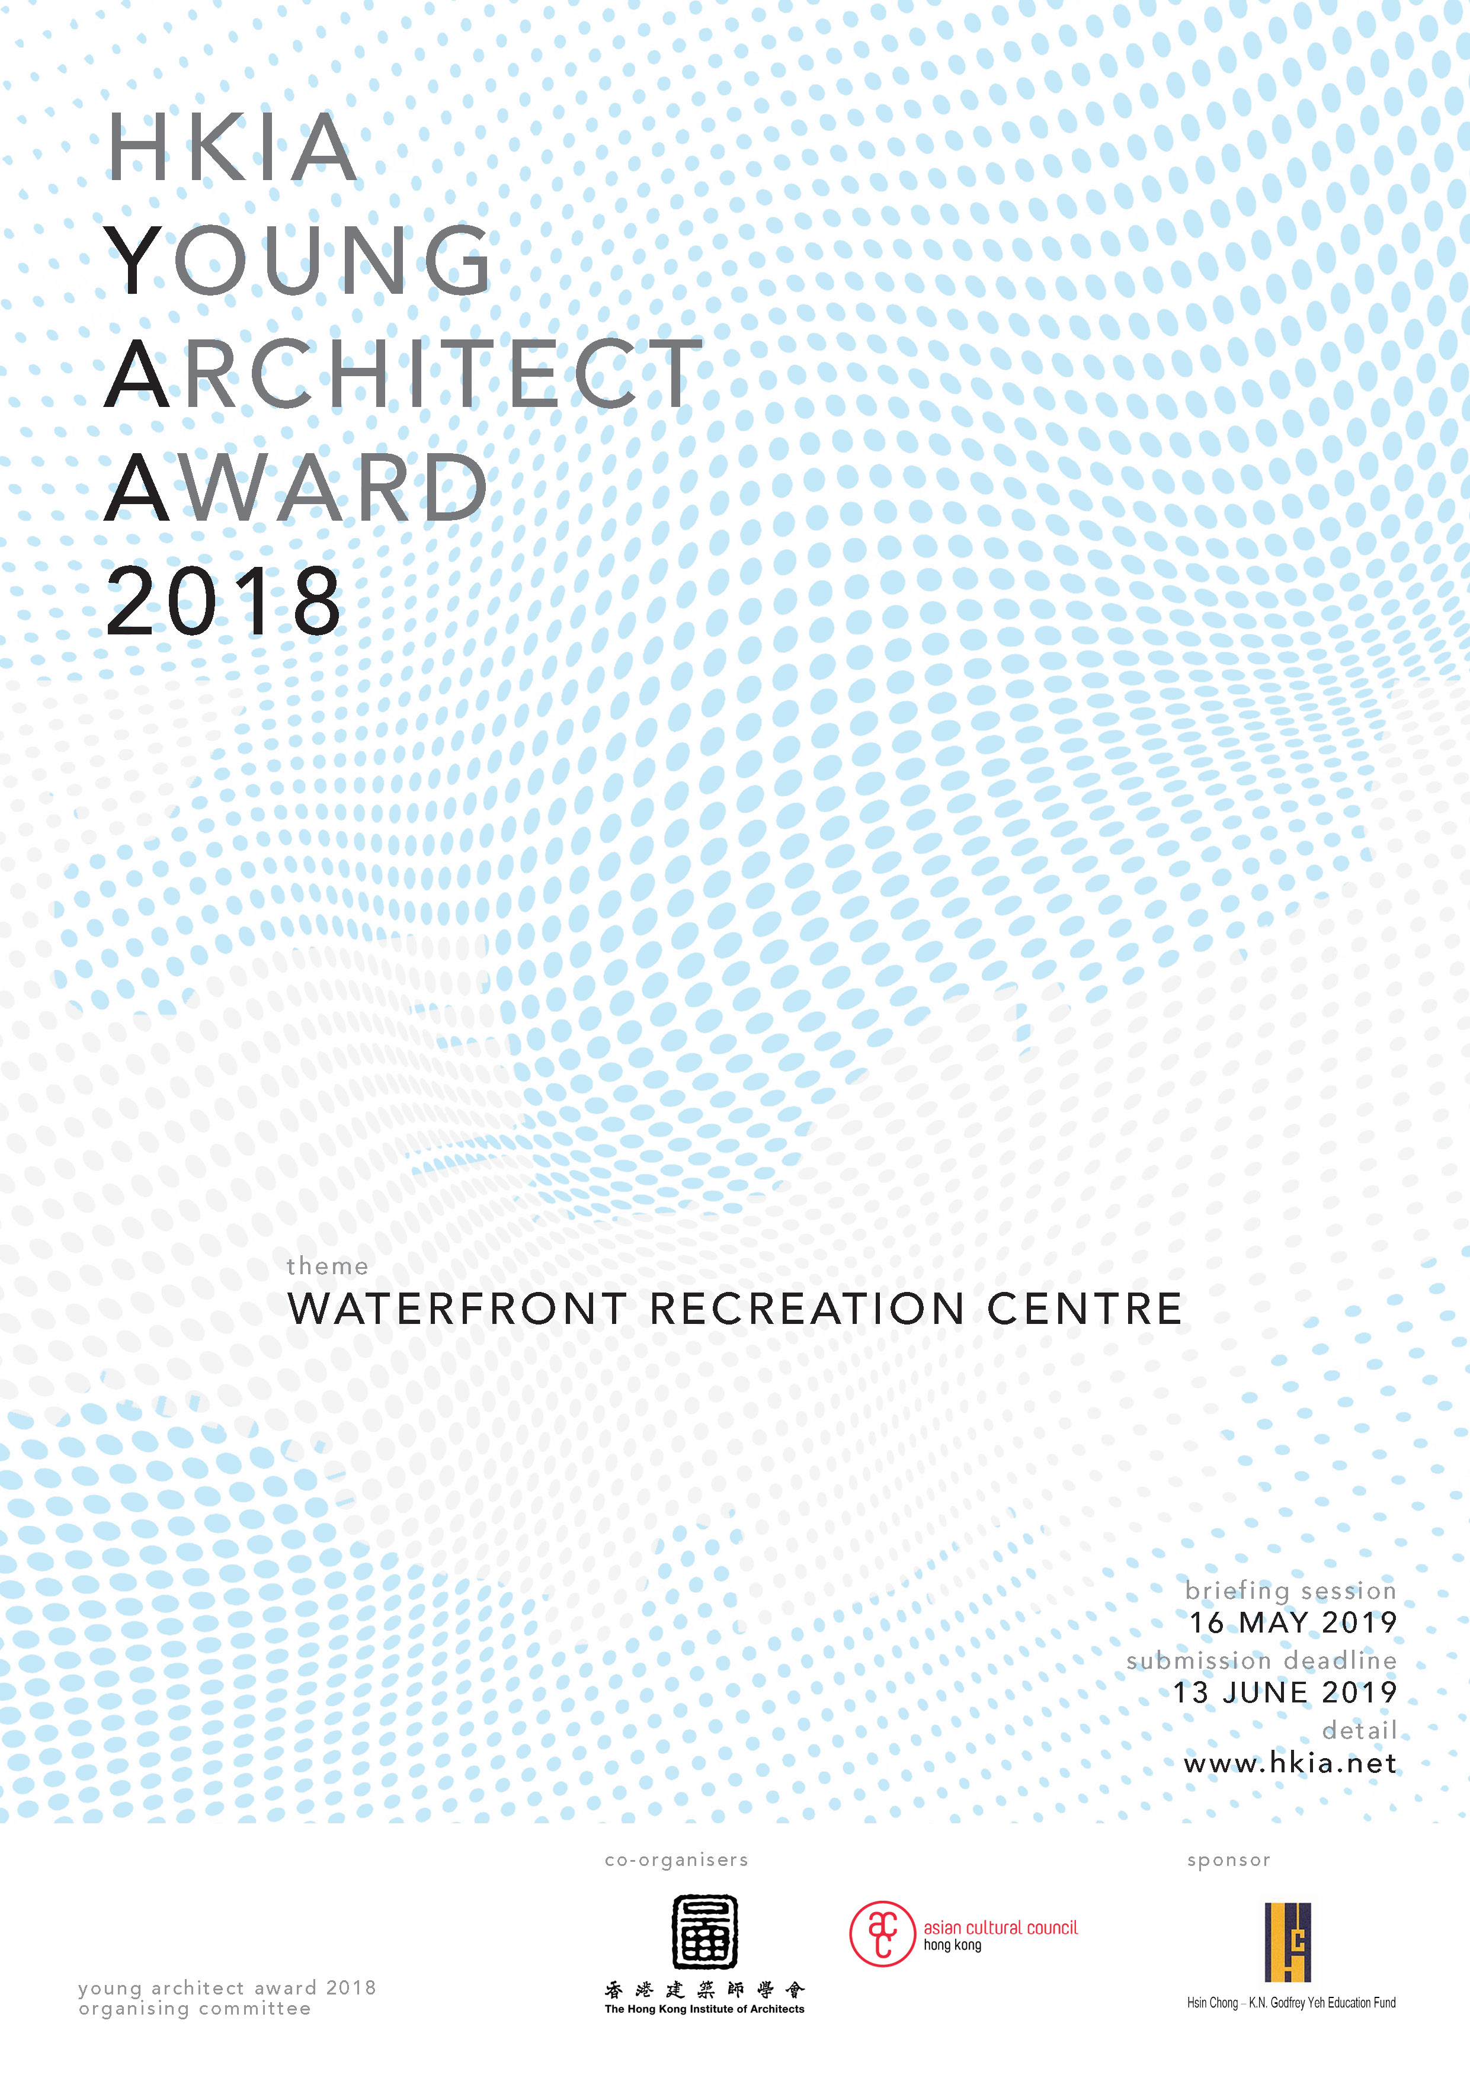
HKIA YOUNG ARCHITECT AWARD [YAA] 2018

CO-ORGANIZERS
The Hong Kong Institute of Architects [HKIA] http://www.hkia.net

Asian Cultural Council, Hong Kong [ACC] http://www.asianculturalcouncil.org
SPONSOR
Hsin Chong - K. N. Godfrey Yeh Education Fund

OBJECTIVE

To honour and acknowledge the talents and contribution of young architects in Hong Kong

ELIGIBILITY

- Member of HKIA
- Aged from 26 to 35 on 31 December 2018
(Date of birth from 1 January 1983 to 31 December 1992)

SELECTION CRITERIA

- Quality of Design Proposal for this Young Architect Award
- Quality of Previous Personal Work
- Professional and Social Achievement and Participation
- Architectural Study Proposal in the United States

AWARD

WINNING ENTRY

- HKIA Young Architect Award Trophy
- A 3-week Architectural Study Trip to the United States
Itinerary - To be proposed by the participant as part of the Submission Criteria
and coordinated by the Asian Cultural Council Hong Kong
- Winning design panel to be displayed at HKIA Premises and HKIA Annual Awards Exhibition
- Publication at HKIA Annual Awards Publication, HKIA Journal and other external media

OBLIGATION

- To join HKIA Young Members Group and to encourage young members to participate in HKIA affairs.
- To represent the HKIA in participating the professional events organized or recommended by Asian Cultural Council.
- To report back to HKIA after his/her Architectural Study Trip.

HKIA YOUNG ARCHITECT AWARD [YAA] 2018

SUBMISSION REQUIREMENT

- Duly completed Entry Form
- Design Proposal in 4 nos. of A2 board with an explanatory statement of the design concepts in English in not more than 500 words printed on one A4 sheet.
[Composition format to be determined by candidate]
- A CD or USB containing electronic copies of
- the above item (i) in doc and pdf format, &
- composite image of the above item (ii) in jpg format (300 dpi)
- Summary of Presentation Documentation and Portfolio of Previous Personal Work
[for short-listed candidates upon request]
- All other submission not listed above is not permitted

SUBMISSION SCHEDULE

Item | Key Date | Remarks
Commencement of YAA Design Competition | 26 April 2019  Friday | HKIA website
Competition Briefing Session | 16 May 2019  Thursday  7:00pm | At HKIA Premises
Registration Deadline | 30 May 2019  Thursday  2:00pm | Completed Registration Form to be submitted to HKIA Secretariat
- Submission Deadline | 13 June 2019  Thursday  2:00pm | Completed Entry Form,  Summary of Presentation Documentation and  Design Panels to be submitted to HKIA Secretariat
- Jury Shortlisting Process | 14 June – 4 July 2019
- Interview of Shortlisted Candidates | 20 July 2019  Saturday | Shortlisted Candidates must attend this Interview Session  at HKIA premises
- Announcement of Result | October 2019 | HKIA website
- Prize Presentation | 3 November 2019 | At HKIA Annual Dinner 2019

HKIA YOUNG ARCHITECT AWARD [YAA] 2018

HKIA YAA JURY PANEL

- Ms. Ada FUNG, BBS, FHKIA - HKIA Past President, Director of World Green Building Council

- Ms. Josephine WAI Representative of Asian Cultural Council, Hong Kong [Co-organizer]

- Mr. Vincent NG, JP HKIA Fellow & Past President

- Mr. Jason TANG HKIA Young Architect Award 2009 Recipient

- Mr. YIP Chun Hang HKIA Young Architect Award 2014 Recipient

HKIA YAA Jury Panel has the final decision on the category and numbers of HKIA Young Architect Award.
Waterfront Recreation Centre
IDEA COMPETITION

DESIGN BRIEF

- BACKGROUND

BETTER HARBOURFRONT

The Victoria Harbour is one of the greatest assets of our city. The 2019 Hong Kong Government Budget Report promises 6 billion to create better and bigger harbourfront promenades, open spaces and harbourfront facilities.

Can a lively experience be provided at this precious strip of land? What kind of facilities and spatial experience can be provided to enhance the sense of community? Can we get closer to the water?

- THEME

AN ENERGETIC HARBOURFRONT FOR THE COMMUNITY

Could we create a harboutfront for all where people can enjoy the stunning views, get active in the water, bathe in the sun, enjoy the sunset, or to meditate on the water?

Participants are to submit Design Proposal for a “Waterfront Recreation Centre”, a facility along the harbour to provide support of water-related activities and recreation, and a place where the local community can enjoy the harbour.

With reference to the Government Budget Plan, it could be a water park or sports facility at the old Wan Chai cargo basin, or a yoga/taichi garden, extreme sports facility or communal farm at he Tin Hai Promenade.

- PROGRAMME

Participants are to propose any programme(s) to demonstrate his/her design vision. The design shall serve to demonstrate creative means to enhance the overall connectivity along the harbour promenade to the rest of the community. Participants may also propose any creative functions or events that provide recreational purpose for the general public.

The proposal shall respect the Protection of the Harbour Ordinance, of which no reclamation or permanent structure shall be added beyond the seashore.

- SCHEDULE OF ACCOMMODATION

Participants are to propose a schedule of accommodation to suit his/her proposal.

- LOCATION

Participant may choose any of the suggested location mentioned above, or to propose any appropriate location along the Victoria Harbour to suit his/her proposal. It is open to the participants to consider undesignated urban space or heritage revitalization.

- BRIEFING SESSION

Design Briefing Session will be held on 16 May 2019 at HKIA premises. Participant makes his/her decision to adopt any reference material presented at the briefing session.

- REFERENCES

Caption from Government Budget Speech 2019, Building the City, Harbourfront Enhancement:
https://www.budget.gov.hk/2019/eng/budget39.html

明報新網, 維港增14公里長廊 公私合營水上活動:
https://news.mingpao.com/pns/要聞/article/20190228/s00001/1551291954038/維港增14公里長廊-公私合營水上活動

Urban Design Study for the Wan Chai North and North Point Harbourfront Areas:
http://www.wcnnpuds.hk/web/publicStage2.php?lang=en

Harbour planning guidelines:
https://www.harbourfront.org.hk/eng/content_page/doc/HEC_guidelines_e.pdf

Cap. 531 Protection of the Harbour Ordinance:
https://www.elegislation.gov.hk/hk/cap531

HKIA YOUNG ARCHITECT AWARD 2018

REGISTRATION FORM

To : HKIA Secretariat Ms. Ellie MAK

Email : bia@hkia.net

Fax : 2519 6011 / 2519 3364
Registration Deadline: On or before 30 May 2019, Thursday, 2:00pm

Name
HKIA Membership No.
E-mail
Tel. |  | Office |  | Mobile

HKIA YOUNG ARCHITECT AWARD 2018

ENTRY FORM

Submission Deadline: On or before 13 June 2019, Thursday, 2:00pm

Name |  |  |  | Chinese
Name |  |  |  | English
HKIA Full Membership No.
E-mail

Mailing Address

Tel. |  | Office |  | Mobile
Education
(in chronological order)
Professional Qualification
(in chronological order)

Note:
1. Please append extra sheets if additional space is required for all the above information
2. The shortlisted candidate will be required to present the above record for reference.

HKIA YOUNG ARCHITECT AWARD 2018

ENTRY FORM

Working Experience
(in chronological order)
Previous Awards, Prizes, Scholarships
Publications / Paper written and/or given
Participation in services to the Profession and the Community

Note:
1. Please append extra sheets if additional space is required for all the above information
2. The shortlisted candidate will be required to present the above record for reference.

HKIA YOUNG ARCHITECT AWARD 2018

ENTRY FORM

Proposed Study Tour

Applicants must agree to spend 3 continuous weeks
in the United States
on a professional visit that will begin no later than October 2019.

Please state itinerary proposal with objective
and visit details including
but not limited to organization / person / architecture / programme / relevant information

[Proposal page 1 of 2]

Note:
1. Please append extra sheets if additional space is required for all the above information
2. The shortlisted candidate will be required to present the above record for reference.

HKIA YOUNG ARCHITECT AWARD 2018

ENTRY FORM

Proposed Study Tour

Applicants must agree to spend 3 continuous weeks
in the United States
on a professional visit that will begin no later than October 2019.

Please state itinerary proposal with objective
and visit details including
but not limited to organization / person / architecture / programme / relevant information

[Proposal page 2 of 2]

Note:
1. Please append extra sheets if additional space is required for all the above information
2. The shortlisted candidate will be required to present the above record for reference.

HKIA YOUNG ARCHITECT AWARD 2018

ENTRY FORM

Professional Reference

Name and Address of 2 nos. of Referees proposed by the candidate.
The Jury may contact the captioned Referees of the shortlisted candidate for further assessment and reference.

1st Referee

Name |  | Chinese
Name |  | English
E-mail
Mailing Address
Tel. |  | Office
Fax |  | Office
2nd Referee

Name |  | Chinese
Name |  | English
E-mail
Mailing Address
Tel. |  | Office
Fax |  | Office

______________________________________ ____________________________
Signature of Candidate Date

Note:
1. Please append extra sheets if additional space is required for all the above information
2. The shortlisted candidate will be required to present the above record for reference.

HKIA YOUNG ARCHITECT AWARD 2018

SUMMARY OF PRESENTATION DOCUMENTATION &

PORTFOLIO OF PREVIOUS PERSONAL WORK

Shortlisted candidate will be required to attend interview session with supporting documentation to demonstrate idea and achievement as follows:

Quality of Design Proposal
for this YAA

(e.g. Research & reference document)
Quality of Previous Personal Work

(e.g. Portfolio with the project names to be stated herein)
Professional and Social Achievement and Participation

(e.g. Portfolio with the project names to be stated herein)
Architectural Study Proposal in the United States

(e.g. Research & reference document)

Note:
1. Please append extra sheets if additional space is required for all the above information
2. The shortlisted candidate will be required to present the above record for reference.

